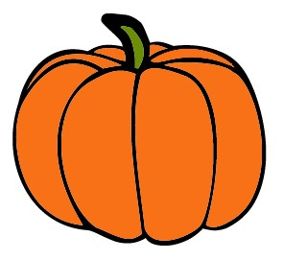
ALVECHURCH PUMPKIN FESTIVAL
Saturday 28th October 11:00am – 4:00pm
Entry Form
How to enter Alvechurch Pumpkin Festival.
Step 1: Grow, carve, knit, paint, crochet (etc..) your pumpkin.
Step 2: Email alvechurchpumpkins@gmail.com by 21st October to let us know you will be entering the competition – include all the details listed below. If you are unable to email, simply complete the details below and hand the completed form to the lovely people at the Lounge.
Step 3: Deliver your pumpkin to Alvechurch Village Hall on Friday 27th October, between 4:00pm and 7:00pm, and pay the £1:00 entry fee.
Step 4: Visit the Village Hall on Saturday 28th October between 11:00am and 4:00pm to see your pumpkin exhibited along with all the other entries! Pumpkin related refreshments will be available!
All proceeds are in aid of the Village Hall and Papyrus.

Name………………………………………………………………………………………….
Age (if under 16)……………Contact Number…………………………………
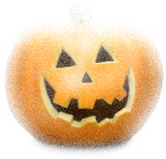
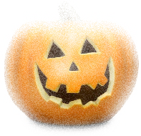
Type of entry: Home grown Home grown and carved Carved Craft
Entry fee is £1:00 per entry
Alvechurch Pumpkin Festival is sponsored by Bromsgrove District Council
ALVECHURCH PUMPKIN FESTIVAL
Saturday 28th October 11:00am – 4:00pm
Entry Form
How to enter Alvechurch Pumpkin Festival.
Step 1: Grow, carve, knit, paint, crochet (etc..) your pumpkin.
Step 2: Email alvechurchpumpkins@gmail.com by 21st October to let us know you will be entering the competition – include all the details listed below. If you are unable to email, simply complete the details below and hand the completed form to the lovely people at the Lounge.
Step 3: Deliver your pumpkin to Alvechurch Village Hall on Friday 27th October, between 4:00pm and 7:00pm, and pay the £1:00 entry fee.
Step 4: Visit the Village Hall on Saturday 28th October between 11:00am and 4:00pm to see your pumpkin exhibited along with all the other entries! Pumpkin related refreshments will be available!
All proceeds are in aid of the Village Hall and Papyrus.

Name………………………………………………………………………………………….
Age (if under 16)……………Contact Number…………………………………
Type of entry: Home grown Home grown and carved Carved Craft
Entry fee is £1:00 per entry
Alvechurch Pumpkin Festival is sponsored by Bromsgrove District Council

